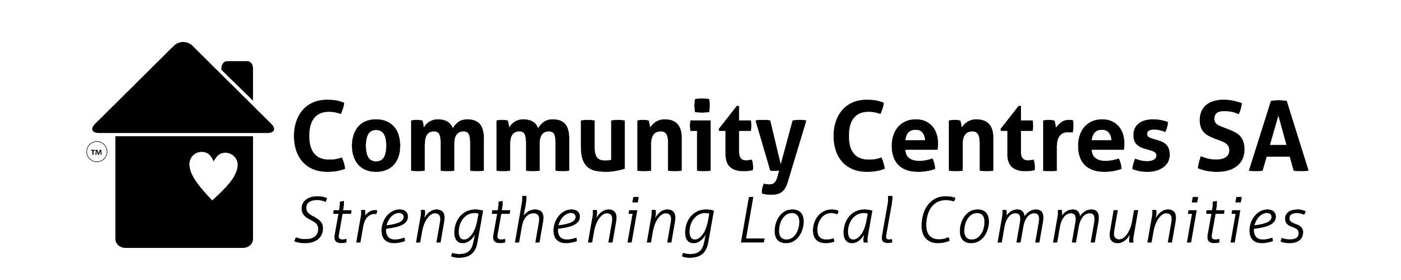

Table A: Comprehensive Centre User Data

Main Age Group
e.g. Pre-School /School /Young Adult /Workforce /Retirement /Senior Other (X%)
Aboriginal and Torres Strait Islander X (X%)
Main Language Spoken X (%)
(other than English)
Lives in Your Council Area
Yes X (X%) No X (X%)
First time Centre User X (X%)
Have a Disability X (X%)
Culturally & Linguistically
Diverse X (X%)
Gender
Female X (X%) Male X (X%) Other X (X%)
Centre User Group

No. Participants

1. Centre-Run Programs
e.g. Yoga | 10 | Senior | F 10 (100%) | 0 | 0 | - | - | Y 3 (30%)  N 7 (70%) | Y 9 (90%)  N 1 (10%)
2. Other Programs or Regular Hirers
3. Community Events
4. Centre Volunteers
OPTIONAL
5. One-off Info Sessions
6. Casual Hirers

X = Number X% = % of total number
LEGEN D

1

